**­Diving deeper than regional average species distribution shifts: fine-scale dynamics of abundance distribution reveal nuanced spatial changes in complex marine ecosystems**

Alternate titles:

Is the mean meaningful? Beyond regional average species distributions shifts towards fine-scale descriptors of spatially varying temporal trends

Simultaneous modeling of spatial density and spatial trends to reveal nuanced changes in complex marine ecosystems

Change isn’t constant: modeling spatially varying temporal trends to identify hotspots of change for west coast groundfishes

The times they are a changing, but not the same way everywhere: modeling spatially varying temporal trends to identify hotspots of change for west coast groundfishes

**Introduction**

In the fields of natural resource conservation, management and global change biology, demand for—and implementation of—tools for assessing species distribution shifts has grown dramatically in recent decades (Elith and Leathwick 2009). However, the way distribution shifts are quantified has changed relatively little (Elith et al. 2010). At the simplest level, researchers often use canned approaches to estimating occurrence probability, presenting maps of how the extent and distribution of suitable habitat is expected to change and perhaps some descriptive statistics on the mean change throughout a region (Yackulic et al. 2013). When reliable abundance data are available distribution shifts are better quantified by spatial predictions of population density, as the notion that the distribution of abundance within a species range is greatest at the center and declines smoothly toward the range edge (the abundant-center hypothesis) has been debunked (Sagarin and Gaines 2002, Sagarin et al. 2006). Such results are conveyed through maps but also simplistic spatial indicators such as the mean location weighted by abundance (also termed the center of gravity, COG).

In reality, abundance distributions are often quite complex and heterogeneous, even when barriers to dispersal are minimal (cite), let alone in typical marine ecosystems where complex coastline and bathymetric topography and geology interact with physical oceanographic drivers (cite). This heterogeneity may also be present in the change in the spatial distribution of abundance over time, and consequently, attempting to describe a shift in species distribution across a broad geographic scale can be misleading, particularly when different regions exhibit contrasting trends. For example, if densities increase at opposing range boundaries at an equivalent rate, there may be no trend in the range-wide COG, masking these finer-scale shifts. Thus, when using spatial indicators to describe species distribution shifts, the spatial scale of aggregation can affect the inference, as in the classic problem of pattern and scale in ecology (Levin 1992). Therefore, there is a general need to develop objective methods for defining appropriate scales to evaluate changes in species distributions. Such tools could help solve specific problems in fish and wildlife conservation and management by defining spatial domains with distinct population dynamics.

Sustainable fisheries management relies on precise and unbiased estimates of fish density when setting acceptable harvest levels. The most reliable estimates of relative fish density are generally derived from fishery-independent survey data; these surveys may also collect additional information valuable in inferring population status, such as age or sex structure, maturation schedules, and variability in recruitment (Hilborn and Walters 1992). In addition to providing data used for managing individual fish populations, fishery-independent survey data may also be used to provide indicators for ecosystem assessments (Nicholson and Jennings 2004, Harvey et al. 2018), understanding the impacts of fishing on non-target or bycatch species Sustainable fisheries management relies on precise and unbiased estimates of fish density when setting acceptable harvest levels. The most reliable estimates of relative fish density are generally derived from fishery-independent survey data; these surveys may also collect additional information valuable in inferring population status, such as age or sex structure, maturation schedules, and variability in recruitment (Hilborn and Walters 1992). In addition to providing data used for managing individual fish populations, fishery-independent survey data may also be used to provide indicators for ecosystem assessments (Nicholson and Jennings 2004, Harvey et al. 2018), understanding the impacts of fishing on non-target or bycatch species (Stock et al. 2019), or informing reference points in applications of ecosystem based fisheries management (Link et al. 2002).

Techniques for estimating fish densities from fishery-independent survey data have evolved rapidly over the last 5 years. The largest methodological changes have been advances in spatiotemporal modeling that have modeled space continuously and explicitly accounted for spatial autocorrelation between spatially-referenced observations that are proximate in both space and time (Shelton et al. 2014, Thorson et al. 2015). These newer analytical approaches have replaced conventional design- or strata-based estimators, which assume that density is homogenous within strata and do not account for spatial arrangement (Chen et al. 2004). As spatiotemporal modeling tools have become accessible in open source software, such as VAST (Thorson 2019) these approaches have been applied to fisheries stock assessments in diverse ecosystems around the world. In addition to being used for stock assessment, these spatial modeling approaches have been used to generate model-based summaries to track change in species distributions, including center of gravity (COG) or area occupied, with more robust estimation than those provided by design-based estimates (Thorson et al. 2016).

There are a number of advantages of estimating relative density in a framework that accounts for spatial or spatiotemporal variation. First, explicitly accounting for spatial variation in density has been shown to increase precision of estimated trends for single species (Thorson et al. 2015). Second, the GLMM framework used in the majority of approaches for modeling spatial or spatiotemporal variation in fish density is extremely flexible and extendable. In the GLMM framework the spatial or spatiotemporal components are typically estimated as random effects (Latimer et al. 2009, Shelton et al. 2014) while the temporal deviations are estimated as fixed effects (factors) to allow for unbiased estimates of trends. Additional extensions include the incorporation of covariates such as depth (Johnson et al. 2019), modeling extremes in spatial processes (Anderson and Ward 2019) or using non-Gaussian families for the response variable to better capture both zeros and extremes (Shono 2008).

For applications with relatively short time series of survey data, or those focused on informing managers or stakeholders, conveying information about spatial trends from existing spatiotemporal models may be complicated. The challenges are similar to a non-spatial setting, as in a linear mixed model with yearly deviations modeled as random effects. Focal questions of interest may include how the estimated deviations change through time, or whether they are autocorrelated. Similar to the non-spatial case, recently developed spatiotemporal modeling approaches have all treated time as a discrete factor, and assumed the predicted spatial distribution of density to be constant across time (modeled as a single spatial field) or variable over time (with variability modeled either as independent over time, or as an autoregressive process).

The objective of this manuscript is to introduce a new modeling approach, incorporating spatial variability in fish density, explicitly estimating spatial variability in changes through time (trend) and random spatiotemporal variation. We apply this novel method to both simulated data, and a case study for groundfish species from the west coast of the United States based on a 15 year trawl survey dataset. We illustrate how our new approach may be used to infer changes over time, and also how output from this modeling approach may be useful in identifying spatial regions where change is greater than or less than average. We demonstrate how model-based COG estimates for these subregions may be more useful than global COG trends calculated over an entire survey domain.

**Methods**

*Spatial GLMM Overview*

The majority of recent applications of SDMs to fisheries data have been implemented in a GLMM (generalized linear mixed‐effects model) framework, where random effects are used to describe and spatial or spatiotemporal components. Spatial components are differentiated from spatiotemporal components in that the former are constant, whereas the latter vary through time. Examples include applications to Gaussian predictive process models (Shelton et al. 2014, Thorson et al. 2015, Anderson and Ward 2019), and predictive modeling using integrated nested Laplace approximations (INLA; (Rue et al. 2009, Ruiz-Cárdenas et al. 2012)). The latter approach has been particularly useful for large datasets, where large gains in computational efficiency are accomplished by taking advantage of sparse matrix approximations to the variance – covariance matrix (Thorson and Barnett 2017). Regardless of the estimation approach used, the general formulation of these models uses a link function $g(∙)$ to relate the observed response to covariates and a latent spatial process. For example,

$g\left(u_{s,t}\right)=X_{s,t}B+{ω_{s}+γ}_{s,t}$,

where $u_{s,t}$ is the expectation at location *s* and time *t*, $X_{s,t}$ are covariates, $B$ represents a vector of estimated coefficients, $ω_{s}$ is the mean spatial component at location *s* (constant through time), and $γ_{s,t}$ is the spatiotemporal process at location *s* and time *t*. The spatiotemporal process describing $γ$ is flexible in that it can be removed from the model (leaving a model with a spatial but no spatiotemporal component), may be independent for each time slice, or modeled with an autoregressive process (allowing hotspots to persist through time; (Thorson et al. 2015, Ward et al. 2015, Anderson and Ward 2019)). Previous applications have either used a delta-GLMM framework to model presence-absence and positive catch rates separately (Thorson et al. 2015) or a Tweedie distribution to model total variation in density (Shono 2008).

Within this GLMM framework, non-stationary changes in the spatial predictions through time can only be modeled with inclusion of covariates, or by modeling spatiotemporal variability as an autoregressive spatial process through time. To explicitly account for non-stationary trends in densities, we propose extending the above framework to include a trend parameter as an additional spatial field. Extending the model above, this becomes

$g\left(u_{s,t}\right)=X_{s,t}B+{ω_{s}+γ}_{s,t}+{t∙z}_{s}$,

where $z_{s}$ represents the spatially varying temporal trend. See Figure 1 for a visualization of the differences between models with and without this spatial trend.

*Testing the ability to recover spatial trends*

To evaluate our ability to recover an added spatial field representing the trend, we conducted a simulation analysis. Given results from previous work with state space models (cite), we focused our simulations on understanding how the magnitude of spatiotemporal variation or observation error variation affect our ability to recover the spatial trend. The simulations were conducted as follows: for each value of spatiotemporal variation and observation error, we simulated a random 10x10 spatial field. We then simulated a latent or unseen spatiotemporal process on this field over 10 time steps, using spatial and spatiotemporal components (modeled as independent random effects) along with a spatial field representing the temporal trend. To include measurement or observation error, we simulated normally distributed data from this spatiotemporal process, with a constant observation error variance. We then fit a spatial GLMM to the simulated data, and assumed the model structure to be known. Estimated values of the spatial trend at the locations of the data were vectorized for each simulation, and used with the true latent field to generate statistical summaries (bias, variance, correlations between predicted and observed values). For each combination of parameter values, we simulated 100 random datasets. Code to replicate this analysis is included in the repository for this project.

*West coast groundfish case study*

As an example application, we fit the spatial trend model to groundfish CPUE from a fishery-independent survey along the US west coast: the NOAA Fisheries, Northwest Fisheries Science Center, US West Coast Groundfish Bottom Trawl Survey (Keller et al. 2017). This survey collects an average of more than 600 samples per year from May to October at depths from 55 to 1280 m, from the US-Canada border to the US-Mexico border. We analyzed the 2003–2018 surveys, which consisted of 10,354 hauls, where locations were selected randomly on trawlable seafloor habitat (i.e., areas without extensive rocks or boulders) stratified by depth and latitude. This survey represents an ideal case study, because it has been used extensively in testing new index standardization methods for stock assessments (Thorson et al. 2015), is publicly available (<https://www.nwfsc.noaa.gov/data/map>), and has been used to develop coastwide indicators, including shifts in center of gravity (Thorson et al. 2016). We selected 19 species of groundfish to model in this analysis, chosen based on a combination of high commercial landings, market value, conservation concern, and prevalence in the survey data (Table S1).

To evaluate whether GLMM with a spatial trend may be appropriate for modeling densities of these 19 species, we first fit spatial GLMMs with and without a spatial trend to each species. We allowed both models to include spatial and spatiotemporal components (independent random effects), depth modeled as a quadratic fixed effect (Thorson et al. 2015), and year as a factor. Spatial components were modeled as random fields, using a triangulated mesh with vertices at 350 knots to approximate a continuous spatial field. The inclusion of year as a factor allowed densities to vary non-linearly over time, and centered each of the estimated spatiotemporal fields to have mean zero. Because of the skewed distribution of CPUE and presence of zeros, we modeled the response for both models with a Tweedie distribution (using log link) (Shono 2008). All estimation was done in R (R Core Team 2018) in a maximum likelihood framework, using the package sdmTMB (cite Sean) which interfaces automatic differentiation in Template Model Builder (Kristensen et al. 2016) with INLA (Rue et al. 2009). Because we were interested in comparing models with different random effects structures (with and without the spatial trend field), we used restricted maximum likelihood (REML, Zuur et al. 2009) to generate Akaike’s Information Criterion values for each (AIC, (Akaike 1973)). Using AIC as a model screening tool, we found broad support for the inclusion of the spatial trend for these 19 species, with the trend model generating lower AIC values in 17 of the 19 cases, and AIC scores differed by less than 2 in the remaining 2 cases (Table S2).

We used estimates from each of the 19 models described above to make predictions on a standardized grid within the survey domain. To obtain a smooth surface of predicted density across the footprint of the survey area, we predicted biomass density from the spatial trend models using depth defined by NOAA bathymetry data (https://www.ngdc.noaa.gov/mgg/coastal/crm.html), averaged over space to match the resolution of the survey sampling grid (~2.8 x 3.7 km), which is the spatial resolution we used for all analyses. A number of diagnostics could be made to these predictions or raw model fits to diagnose whether a spatial trend may be appropriate. Examples include examining spatial patterns in residuals or the estimated spatiotemporal component.

*Using spatial trends as indicators of change*

To aid in interpretation, and utility as a potential spatial indicator within the California Current, we performed post-hoc clustering of predicted spatial trends and intercept fields. We used the partitioning around mediods algorithm in the fpc R library (Hennig 2019) to classify responses of each surface, using the predictions (trend or intercept) and latitude as response variables, given that the majority of the contrast in dynamics along the US west coast is in the latitudinal direction. Other metrics could also be included in clustering – including longitude, habitat features, environmental covariates, or human impacts such as fishing removals.

**Results**

*Simulation testing*

Results from our simulation indicated that, as expected, both observation error variation and spatiotemporal variation degraded our ability to estimate the true latent spatial trend (Fig. 2). When both variance parameters are small, estimates are precisely estimated and unbiased, however large values of either can destroy the ability to recover the trend (Fig. 2). The performance of these models is also conditional on additional parameters and structure not included in our sensitivity analysis (spatial decay and variation parameters, data simulated with a normal distribution), however these results indicate that spatiotemporal variation has a slightly larger effect on our ability to recover trends than does observation error (Fig. 2, compare rows).

*West coast groundfish case study*

Predictions of the spatially-explicit trend and intercept from the GLMM revealed intricate fine-scale spatial structure and dynamics in US west coast groundfish distributions. Below, we highlight results for 6 species which demonstrated unique distributional responses (Fig. 3; see Figs. S1, S2 for results from all 19 species). Applying a partitioning algorithm to the combination of latitude and spatial trend or intercept helped delineate areas with the greatest contrast in density or change in density over time. Within each of six species of groundfish, there was support for 2-3 clusters for the trend (Fig. 3). Comparison of the spatial trend predictions and clusters revealed how several unique patterns of subregional relationships can contribute to nuanced and difficult to detect broad-scale distributional changes including northward, southward, and bi-directional range shifts, in addition to localized offshore shifts. Furthermore, the interpretation of the observed distributional change often varied between spatial scales of interpretation, along the spectrum from the fine-scale map-based interpretation to summarizing trends in the coastwide latitudinal center of gravity (COG).

Direct interpretation of the mapped predictions of the spatial intercept and trend indicated that arrowtooth flounder and shortspine thornyhead had southward range shifts, yet the COG inferences differed to some degree between species. For example, the predicted spatial intercepts indicate that arrowtooth flounder (Fig. 3, first row) was typically most prevalent in the northern half of the region, yet the spatial trend pattern indicates that their density is increasing at the highest rate in the central region, indicating a southward range expansion manifesting from high productivity at, or movement toward, the range edge. The time series of the coastwide COG (thick grey line in last column of Fig. 3) also indicates a southward shift, yet it appears slight and the interpretation is not as clear because the coastwide pattern is heavily weighted by the high densities in the far northern portion of the study area. However, when the COG is expressed as a time series computed on each area defined by the trend clusters (colored lines in last column of Fig. 3), the convergence of the COG trend in the north and south provides the additional context necessary to detect that the change is due to increased density in the central region. For other species, even the cluster-specific COG does not accurately capture the nuanced spatial changes. For example, shortspine thornyhead is distributed coastwide, yet similarly to arrowtooth flounder, they are more abundant in the north and increasing fastest in the north-central area (Fig. 3, last row). In this case, the coastwide COG indicates a northward distribution shift, yet the cluster-specific COG indicates converging trends: slightly southward shifting of the northern cluster and slight northward shift in the central region.

The spatial intercept and trend maps indicated northward range shifts for bocaccio rockfish, where the former also had a localized shift in longitude from nearer to further from shore in the northern portion of the region. Both species were typically more abundant in the southern and central areas, yet were experiencing the fastest increases in density in the north. These observations contrast with those from the COG, where the coastwide COG for bocaccio is highly variable with either no trend or a very slight southward trend, yet the COG of the northern cluster indicates a southward shift among some years.

A bi-directional or divergent range shift was observed in the spatial trend of English sole, which is typically present in relatively similar densities coastwide. However, the coastwide COG reveals only a slight southward shift, while the cluster-specific COGs have only a slight northward shift in the northern region.

No range shift was apparent in maps of the spatial trend and intercept for sablefish, yet the coastwide COG timeseries indicated that a northward shift had occurred in the most recent 5-6 years. The cluster-specific COG indicates that this was driven by density changes in the northern and to some extent central regions. Thus, depending on the evidence used, one could either conclude that there was a recent northward range shift, or simply an increase in productivity or aggregation near the core of the range within the north-central area.

Among all groundfishes modeled, typically at least one of the breaks between trend and latitude clusters occurred at a latitude corresponding to an accepted biogeographic break (Fig. 4). These locations of similarity between the boundary of the spatial trend clusters occurred most often near Point Conception in southern California, and Cape Mendocino in northern California. Approximately 16-17 species had cluster boundaries near Cape Mendocino, with roughly 8 near Point Conception, and only ~3 had breaks that primarily resided outside of the area between Cape Mendocino and Point Conception. Despite this congruity with established biogeographic boundaries, there was substantial variability among species in the precise location of the boundary of the spatial trend cluster.

**Discussion**

Ecosystems are often complex in their spatial distribution of biotic and abiotic drivers of population productivity and habitat suitability, suggesting that fine-scale descriptors may provide a more accurate representation of changes in species distributions than global indicators calculated across an entire region. Here, we introduced a new approach to modeling and summarizing spatially-referenced time series data on species abundances to calculate area-specific trends in population density. Our proposed method did recover simulated spatial trends and revealed nuanced spatial trends in fishery-independent survey data that indicated inferences that often differed from that obtained by traditional global descriptors of species distribution shifts (Woillez et al. 2009, Pinsky et al. 2013, Thorson et al. 2016). Furthermore, the ability of our models to detect geographic boundaries between regions with different trends was affirmed as these boundaries were largely congruent with known biogeographic breaks.

Simulations indicated that our spatial trend model is robust to model misspecification, but somewhat sensitive to observation error and spatiotemporal variation. Such sources of variation can obscure the spatial trend, yet this is to be expected in the same way that any trend is less detectable given greater noise in the data (one general citation/one more specific to spatiotemporal models). Therefore, we assert that our method may be generally skillful at detecting spatial structure in population or community dynamics from observations with precise measurement within systems with low temporal variation in spatial structure (e.g., those consisting of species with slower life histories and lower variation in dispersal paths). [Make the observation error threshold tangible by indicating some examples of data types where robust estimates would not be possible to obtain?]

We show how the inference about shifts in species distribution or productivity depend on the spatial scale at which they are summarized. When we applied the model to the data in our case study, the resulting maps of the spatially-explicit trend and intercept from the spatiotemporal GLMM revealed nuanced patterns of heterogeneity and directional change in groundfish biomass distributions beyond which was detected by coastwide center of gravity (COG; this study, (Thorson et al. 2016)). Taking the intercept random field to represent the underlying spatial heterogeneity, the trend random field conveyed fine-scale information about potential range dynamics that often differed from related inferences made by evaluating time series of the coastwide COG of predicted density. The disparity of inference was greatest in cases where density was increasing fastest at opposing ends of a range, a divergent shift, or where densities among patches were converging toward the center of the distribution. Furthermore, from the coastwide COG, without further investigation one is unable to differentiate between shifts due to an increase in density in one dimension or a decrease in density in the opposite dimension. However, partitioning by latitude and trend identified clusters of locations, within which the COG of predicted density still has promise as a useful summary statistic of distribution shifts.

For complex ecosystems such as the US west coast and other coastal upwelling systems, where physical variables like temperature do not follow a simple monotonic gradient over broad geographic scales, it may be too simplistic to expect clear coastwide trends in COG across multiple species as a result of climate change. These types of patterns are observed in systems with broader continental shelves like the northeast US (Pinsky et al. 2013, Kleisner et al. 2016), yet along coastlines with narrower continental margins, depending on the orientation and slope of the bathymetry, fish may be able to find equivalent temperatures by moving much shorter distances perpendicular to the shelf break. Furthermore, population and community biomass is inherently patchy, meaning that detecting meaningful redistribution over time may require careful examination of the microstructure of biomass distribution rather than a region-wide shift in mean biomass distribution. We encourage future research on species distribution shifts that begins with more specific and nuanced hypotheses regarding the expected response. For example, if climate change causes a global intensification of upwelling as some researchers predict (Bakun et al. 2010), one could hypothesize that biomass distributions will become patchier over time in response to increasing contrast in local physical conditions, or that distributions will shift deeper as larvae are transported further offshore before settling.

The future of fisheries and wildlife management relies on greater incorporation of spatial information into models and decision-making processes (Berger et al. 2017, Lowerre-Barbieri et al. 2019). By defining the geography of population trends and the breaks between clusters of locations with similar trends, our modeling framework provides a data-driven method to objectively define the spatial scale and boundaries for summarizing monitoring data and structuring these inputs to resource management models. This is an important advancement over non-spatial resource assessments or the reliance on the use of jurisdictional boundaries to structure assessments. Our vision is that these and subsequent methods for boundary detection will aid the development of spatial fishery stock assessment models and stimulate further applications of such approaches to more disparate management solutions such as invasive species management.

Our proposed framework for analyzing spatial trends does have some limitations. Chiefly, it assumes that the local trend can be well estimated by a linear relationship. The validity of this assumption will be data dependent, for example, this may be a more reasonable assumption when time series are relatively short and/or local population dynamics are highly autocorrelated. The fit of the model will need to be examined on a case-by-case basis, but this is not a unique problem. In general, we argue that the inferential benefits of linear models like this outweigh the lack of flexibility to fit non-linear local responses. In this specific case, the linear trend is critical to communicate the spatial trend of many locations on a map in a simple 2D image.

[Concluding paragraph]



Figure 1. Visualization of the spatiotemporal component of a GLMM, with and without a spatial trend (spatiotemporal fields in time steps 1, 5, and 10 are shown). In the absence of a trend the spatiotemporal fields offer a flexible approach to model the data, though there is a persistent trend in the fields over time. After removing this trend, spatiotemporal fields are included to explain the residual spatial variation.



Figure 2. Results from the simulation models, used to estimate the effects of observation error variation and spatiotemporal variation on the ability to recover the spatial trend. Each violin represents 100 simulations: for each parameter, the standard deviation of the other parameter is held at 0.01.

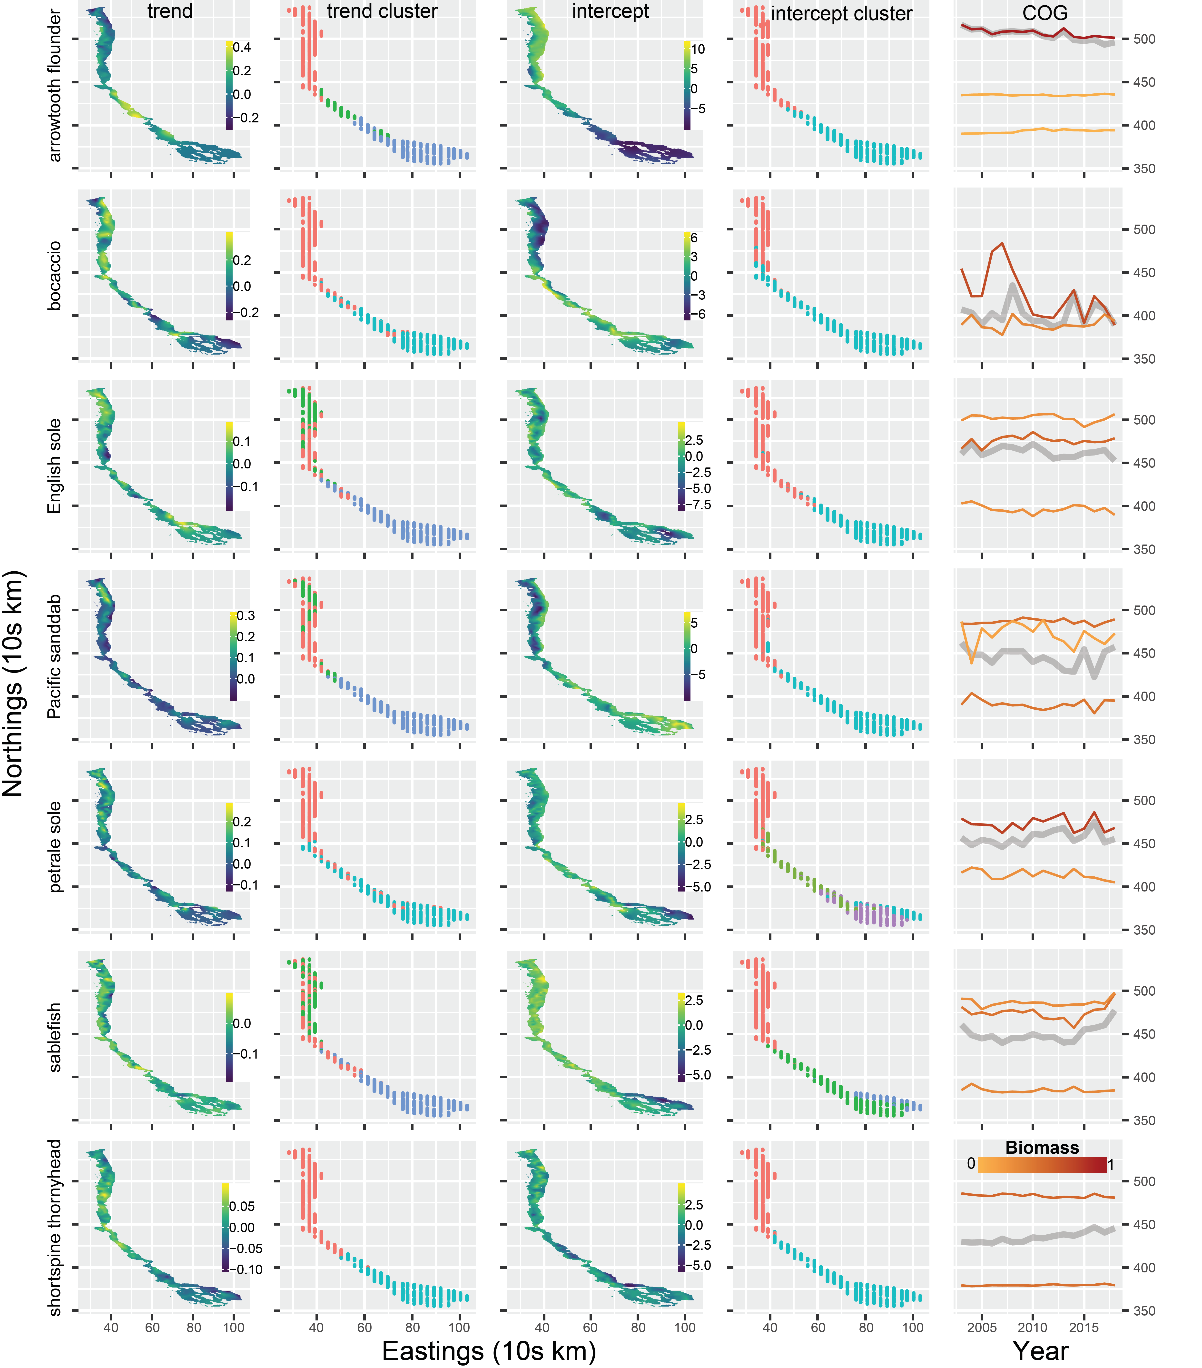

Figure 3. Spatial and temporal patterns of predicted density for selected species. The first column shows maps of the predicted spatial trend (slope of log density across years). The second and column shows how each spatial location groups with a unique cluster of latitude and spatial trend. The fourth column shows the time series of the center of gravity (COG), or density-weighted mean latitude with 95% confidence intervals. The black line with grey interval represents the COG calculated on coastwide predicted species density, whereas the colored lines are the COGs for each unique biogeographic region (separated by Cape Mendocino, California in the north; Point Conception, California in the south). Line color represents the proportion of a species biomass in a given region.



Figure 4. Stripplot showing each unique cluster of latitude and spatial trend in density (slope) by species. Each set of points associated with a given cluster are represented by a different column and colored by their deviation from the mean coastwide trend for a given species. Grey points represent clusters from which the trend (slope) was within 0.01 of the mean coastwide trend. Horizontal lines represent approximate positions of known biogeographic breaks: Cape Mendocino, California in the north; Point Conception, California in the south).

REFERENCES

Akaike, H. 1973. Information theory and an extension of the maximum likelihood principle. Page 2nd International Symposium on Information Theory. Budapest: Akadémiai, Tsahkadsor, Armenia, USSR.

Anderson, S. C., and E. J. Ward. 2019. Black swans in space: modeling spatiotemporal processes with extremes. Ecology 100:e02403.

Bakun, A., D. B. Field, A. Redondo-Rodriguez, and S. J. Weeks. 2010. Greenhouse gas, upwelling-favorable winds, and the future of coastal ocean upwelling ecosystems. Global Change Biology 16:1213–1228.

Berger, A. M., D. R. Goethel, P. D. Lynch, T. Quinn, S. Mormede, J. McKenzie, and A. Dunn. 2017. Space oddity: The mission for spatial integration. Canadian Journal of Fisheries and Aquatic Sciences 74:1698–1716.

Brooks, M. E., K. Kristensen, K. J. van Benthem, A. Magnusson, C. W. Berg, A. Nielsen, H. J. Skaug, M. Mächler, and B. M. Bolker. 2017. glmmTMB Balances Speed and Flexibility Among Packages for Zero-inflated Generalized Linear Mixed Modeling. The R Journal 9:378–400.

Chen, J., M. E. Thompson, and C. Wu. 2004. Estimation of Fish Abundance Indices Based on Scientific Research Trawl Surveys. Biometrics 60:116–123.

Elith, J., M. Kearney, and S. Phillips. 2010. The art of modelling range-shifting species. Methods in Ecology and Evolution 1:330–342.

Elith, J., and J. R. Leathwick. 2009. Species Distribution Models: Ecological Explanation and Prediction Across Space and Time. Annual Review of Ecology, Evolution, and Systematics 40:677–697.

Harvey, C., N. Garfield, G. Williams, N. Tolimieri, I. Schroeder, E. Hazen, K. Andrews, K. Barnas, S. Bograd, R. Brodeur, B. Burke, J. Cope, L. deWitt, J. Field, J. Fisher, T. Good, C. Greene, D. Holland, M. Hunsicker, M. Jacob, S. Kasperski, S. Kim, A. Leising, S. Melin, C. Morgan, B. Muhling, S. Munsch, K. Norman, W. Peterson, M. Poe, J. Samhouri, W. Sydeman, J. Thayer, A. Thompson, D. Tommasi, A. Varney, B. Wells, T. Williams, J. Zamon, D. Lawson, S. Anderson, J. Gao, M. Litzow, S. McClatchie, E. Ward, and S. Zador. 2018. Ecosystem Status Report of the California Current for 2018: A Summary of Ecosystem Indicators Compiled by the California Current Integrated Ecosystem Assessment Team CCIEA. U.S. DEPARTMENT OF COMMERCE National Oceanic and Atmospheric Administration National Marine Fisheries Service Northwest Fisheries Science Center.

Hennig, C. 2019. Fpc: flexible procedures for clustering.

Hilborn, R., and C. J. Walters. 1992. Quantitative fisheries stock assessment: Choice, dynamics and uncertainty. Chapman & Hall, London.

Johnson, K. F., J. T. Thorson, and A. E. Punt. 2019. Investigating the value of including depth during spatiotemporal index standardization. Fisheries Research 216:126–137.

Keller, A. A., J. R. Wallace, and R. D. Methot. 2017. The Northwest Fisheries Science Center’s West Coast Groundfish Bottom Trawl Survey: History, Design, and Description. NOAA Technical Memorandum, Northwest Fisheries Science Center, Seattle, WA.

Kleisner, K. M., M. J. Fogarty, S. McGee, A. Barnett, P. Fratantoni, J. Greene, J. A. Hare, S. M. Lucey, C. McGuire, J. Odell, V. S. Saba, L. Smith, K. J. Weaver, and M. L. Pinsky. 2016. The Effects of Sub-Regional Climate Velocity on the Distribution and Spatial Extent of Marine Species Assemblages. PLOS ONE 11:e0149220.

Kristensen, K., A. Nielsen, C. W. Berg, H. Skaug, and B. M. Bell. 2016. TMB: Automatic Differentiation and Laplace Approximation. Journal of Statistical Software 70:1–21.

Latimer, A. M., S. Banerjee, H. S. Jr, E. S. Mosher, and J. A. S. Jr. 2009. Hierarchical models facilitate spatial analysis of large data sets: a case study on invasive plant species in the northeastern United States. Ecology Letters 12:144–154.

Levin, S. A. 1992. The problem of pattern and scale in ecology: the Robert H. MacArthur award lecture. Ecology 73:1943–1967.

Link, J. S., J. K. T. Brodziak, S. F. Edwards, W. J. Overholtz, D. Mountain, J. W. Jossi, T. D. Smith, and M. J. Fogarty. 2002. Marine ecosystem assessment in a fisheries management context. Canadian Journal of Fisheries and Aquatic Sciences 59:1429–1440.

Lowerre-Barbieri, S. K., I. A. Catalán, A. Frugård Opdal, and C. Jørgensen. 2019. Preparing for the future: integrating spatial ecology into ecosystem-based management. ICES Journal of Marine Science 76:467–476.

Nicholson, M. D., and S. Jennings. 2004. Testing candidate indicators to support ecosystem-based management: the power of monitoring surveys to detect temporal trends in fish community metrics. ICES Journal of Marine Science 61:35–42.

Pinsky, M. L., B. Worm, M. J. Fogarty, J. L. Sarmiento, and S. A. Levin. 2013. Marine taxa track local climate velocities. Science 341:1239–1242.

R Core Team. 2018. R: A language and environment for statistical computing. Vienna, Austria.

Rue, H., S. Martino, and N. Chopin. 2009. Approximate Bayesian inference for latent Gaussian models by using integrated nested Laplace approximations. Journal of the Royal Statistical Society: Series B (Statistical Methodology) 71:319–392.

Ruiz-Cárdenas, R., E. T. Krainski, and H. Rue. 2012. Direct fitting of dynamic models using integrated nested Laplace approximations — INLA. Computational Statistics & Data Analysis 56:1808–1828.

Shelton, A. O., J. T. Thorson, E. J. Ward, and B. E. Feist. 2014. Spatial semiparametric models improve estimates of species abundance and distribution. Canadian Journal of Fisheries and Aquatic Sciences 71:1655–1666.

Shono, H. 2008. Application of the Tweedie distribution to zero-catch data in CPUE analysis. Fisheries Research 93:154–162.

Stock, B. C., E. J. Ward, T. Eguchi, J. E. Jannot, J. T. Thorson, B. E. Feist, and B. X. Semmens. 2019. Comparing predictions of fisheries bycatch using multiple spatiotemporal species distribution model frameworks. Canadian Journal of Fisheries and Aquatic Sciences.

Thorson, J. T. 2019. Guidance for decisions using the Vector Autoregressive Spatio-Temporal (VAST) package in stock, ecosystem, habitat and climate assessments. Fisheries Research 210:143–161.

Thorson, J. T., and L. A. K. Barnett. 2017. Comparing estimates of abundance trends and distribution shifts using single- and multispecies models of fishes and biogenic habitat. ICES Journal of Marine Science 74:1311–1321.

Thorson, J. T., M. L. Pinsky, and E. J. Ward. 2016. Model-based inference for estimating shifts in species distribution, area occupied and centre of gravity. Methods in Ecology and Evolution 7:990–1002.

Thorson, J. T., A. O. Shelton, E. J. Ward, and H. J. Skaug. 2015. Geostatistical delta-generalized linear mixed models improve precision for estimated abundance indices for West Coast groundfishes. ICES Journal of Marine Science 72:1297–1310.

Ward, E. J., J. E. Jannot, Y.-W. Lee, K. Ono, A. O. Shelton, and J. T. Thorson. 2015. Using spatiotemporal species distribution models to identify temporally evolving hotspots of species co-occurrence. Ecological Applications 25:2198–2209.

Woillez, M., J. Rivoirard, and P. Petitgas. 2009. Notes on survey-based spatial indicators for monitoring fish populations. Aquatic Living Resources 22:155–164.

Yackulic, C. B., R. Chandler, E. F. Zipkin, J. A. Royle, J. D. Nichols, E. H. Campbell Grant, and S. Veran. 2013. Presence-only modelling using MAXENT: when can we trust the inferences? 4:236–243.

APPENDIX TABLES

Table S1. Empirical occurrence and mean catch rates for positive tows (CPUE in kg per km2) for the 19 west coast groundfish species included in our analysis.

|  |  |  |
| --- | --- | --- |
| Species | Occurrence | Mean CPUE |
| arrowtooth flounder | 0.36 | 1535.47 |
| big skate | 0.15 | 826.21 |
| bocaccio | 0.07 | 1116.80 |
| canary rockfish | 0.08 | 3217.57 |
| darkblotched rockfish | 0.18 | 960.41 |
| Dover sole | 0.84 | 2968.49 |
| English sole | 0.41 | 695.70 |
| lingcod | 0.33 | 873.42 |
| longnose skate | 0.60 | 985.95 |
| Pacific halibut | 0.08 | 1031.22 |
| Pacific ocean perch | 0.07 | 2191.36 |
| petrale sole | 0.43 | 909.81 |
| rex sole | 0.62 | 1011.33 |
| sablefish | 0.65 | 1191.93 |
| shortspine thornyhead | 0.51 | 690.99 |
| spiny dogfish | 0.28 | 2819.21 |
| splitnose rockfish | 0.21 | 2619.62 |
| spotted ratfish | 0.50 | 617.10 |
| widow rockfish | 0.04 | 1846.20 |

Table S2. Delta – AIC values comparing spatial GLMMs with and without an estimated spatial trend field. Delta – AIC values are interpreted relative to the best model for each species (0 = most parsimonious model).

|  |  |  |
| --- | --- | --- |
| Species | No spatial trend | Spatial trend |
| arrowtooth flounder | 87.10 | **0.00** |
| big skate | **0.00** | 0.81 |
| bocaccio | 6.25 | **0.00** |
| canary rockfish | 4.55 | **0.00** |
| darkblotched rockfish | 6.30 | **0.00** |
| Dover sole | 88.24 | **0.00** |
| English sole | 45.79 | **0.00** |
| lingcod | 3.43 | **0.00** |
| longnose skate | 28.43 | **0.00** |
| Pacific halibut | **0.00** | 1.90 |
| Pacific ocean perch | 0.67 | **0.00** |
| petrale sole | 25.87 | **0.00** |
| rex sole | 88.61 | **0.00** |
| sablefish | 20.23 | **0.00** |
| shortspine thornyhead | 35.38 | **0.00** |
| spiny dogfish | 38.58 | **0.00** |
| splitnose rockfish | 1.28 | **0.00** |
| spotted ratfish | 15.83 | **0.00** |
| widow rockfish | 5.60 | **0.00** |

APPENDIX FIGURES

Fig S1. Trend/intercept maps and clusters for all species(<https://github.com/ericward-noaa/westcoast_spatial_trends/blob/master/plots/iid_trend/trend_intercept_cluster.pdf>)

Other figures delivered as their own PDF:

1. full predicted density maps by year for all species- <https://github.com/ericward-noaa/westcoast_spatial_trends/blob/master/plots/iid_trend/predicted_density_maps.pdf>

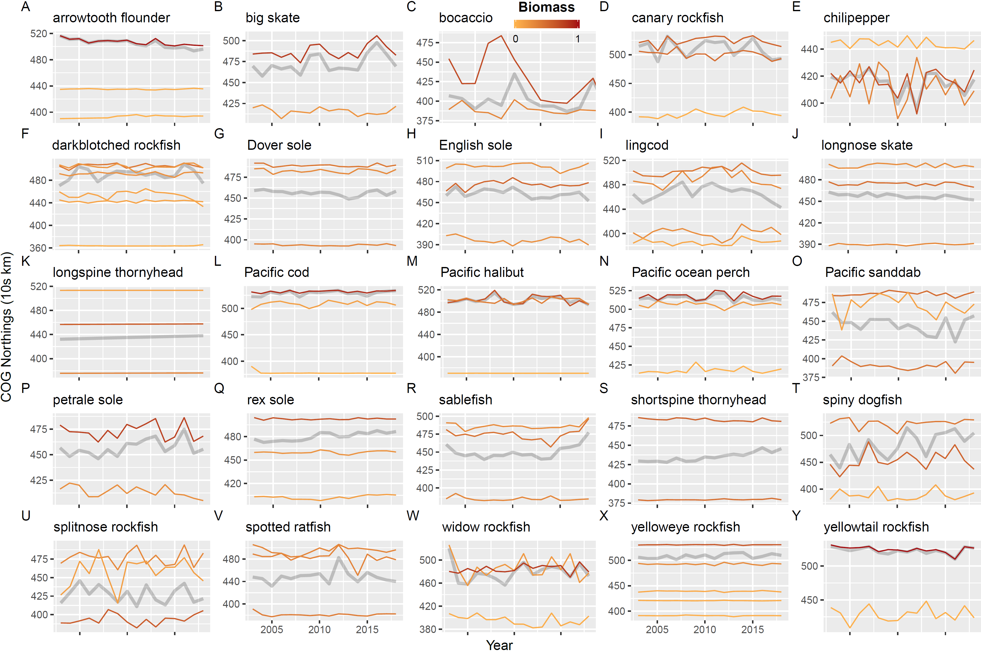

Figure S2. Time series of the center of gravity (COG), or density-weighted mean latitude, for the full set of species analyzed in figure 4 of the main text. The black line with grey interval represents the COG calculated on coastwide predicted species density, whereas the colored lines are the COGs for each unique biogeographic region (separated by Cape Mendocino, California in the north; Point Conception, California in the south). Line color represents the proportion of a species biomass in a given region.